"Experience the Magic of Kerala”
(5N/6D)

Experience the best of Kerala and Kanyakumari on this memorable 6 Days / 5 Nights journey. Explore the colonial charm of Kochi, the misty tea gardens of Munnar, and the tranquil backwaters of Alleppey aboard a traditional houseboat. Relax at the scenic cliffside beaches of Varkala, renowned for their breathtaking coastal views and peaceful ambiance.

Conclude your tour at Kanyakumari, where the Arabian Sea, Bay of Bengal, and Indian Ocean meet in spectacular harmony. Visit iconic landmarks like the Vivekananda Rock Memorial and Thiruvalluvar Statue and witness mesmerizing sunrise or sunset views. Blending nature, culture, heritage, and relaxation, this itinerary is perfect for families, couples, and anyone seeking an unforgettable South India holiday.

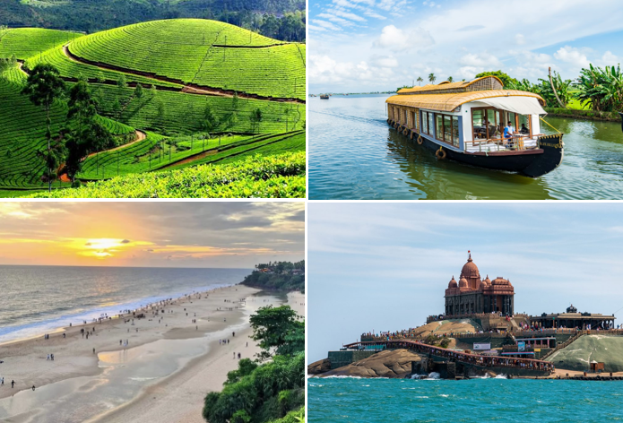

We wish you a happy, safe and unforgettable journey with us
Detailed Itinerary

Day 01: Arrive Kochi – Sightseeing

Upon arrival at Cochin International Airport or Ernakulam Railway Station, meet our representative and transfer to your hotel. After check-in, explore the cultural and colonial charm of Kochi, visiting attractions such as Fort Kochi, the iconic Chinese Fishing Nets, St. Francis Church, Santa Cruz Basilica, Mattancherry Palace (Dutch Palace), and the historic Jew Town. Spend the evening at leisure or shop for spices and local handicrafts before returning to the hotel. Overnight stay in Kochi.

Day 02: Kochi – Munnar (126 Km | 4 Hrs approx.)

After breakfast, check out and drive to the picturesque hill station of Munnar. Enjoy a scenic journey through winding roads, lush tea plantations, spice gardens, and cascading waterfalls. En route, stop at the beautiful Cheeyappara and Valara Waterfalls (seasonal). Upon arrival, check in to your hotel and relax amidst the tranquil surroundings. Overnight stay in Munnar.

Day 03: Munnar – Alleppey (171 Km | 5 Hrs approx.)
After breakfast, visit the popular attractions of Munnar, including Mattupetty Dam, Echo Point, Tea Museum, and Photo Point (subject to time). Later, check out and drive to Alleppey, famously known as the "Venice of the East." Upon arrival, check in to a traditional houseboat or hotel (as per your package) and enjoy a peaceful cruise through the serene backwaters, passing coconut groves, paddy fields, and charming villages. Overnight stay in Alleppey.
Day 04: Alleppey – Varkala (125 Km | 3.5 hrs)
After breakfast, check out and drive to the coastal town of Varkala, renowned for its dramatic cliffs, golden beaches, and peaceful atmosphere. Upon arrival, check in to your hotel and spend the rest of the day relaxing at Varkala Beach, enjoying the stunning Arabian Sea views, or exploring the vibrant cliffside cafés and local markets. Overnight stay in Varkala.
Day 05: Varkala – Kanyakumari ()
After breakfast, check out and proceed to Kanyakumari, the southernmost point of mainland India where the Arabian Sea, Bay of Bengal, and Indian Ocean meet. Visit the iconic Vivekananda Rock Memorial, Thiruvalluvar Statue, Kanyakumari Temple, and the scenic Triveni Sangam. Witness the spectacular sunset over the ocean, a truly unforgettable experience. Overnight stay in Kanyakumari.
Day 06: Kanyakumari – Trivandrum Departure
After breakfast, check out from the hotel and, if time permits, enjoy the beautiful sunrise over Kanyakumari before driving to Trivandrum. En route, you may visit the sacred Padmanabhaswamy Temple (subject to time and temple timings). Later, transfer to Trivandrum International Airport or Railway Station for your onward journey, carrying unforgettable memories of Kerala's misty hills, tranquil backwaters, pristine beaches, and the breathtaking southern tip of India.

Tour ends with unforgettable memories

Destination/Nights | 3* Hotel Name
Kochi / 01N
Munnar /01N
Alleppey /01N | Houseboat
Varkala /01N
Kanyakumari /01N
Hotels Details:

Package Cost:

3★ Hotels: Rs. per person (Based on 6 guests – Double Sharing Basis)

Inclusion: -
- Breakfast Included.
- 0 DBL Room on sharing based.
- 04 Nights in Accommodation in hotel.
- 01 Night in Super Deluxe Houseboat in Alleppey.
- Assistance on Arrival.
- All Transfers and S.S tours by AC [Pick Up Kochi – Drop at Trivandrum]
Exclusions: -
- 5% GST.
- Flight Tickets are not included.
- Guide.
- Extra meal not included or as per the inclusions given above.
- Vehicle not at disposal.
- No extra pickup or drop included for lunch/sightseeing unless otherwise mentioned in the itinerary.

